Types of Governments
Children’s Book

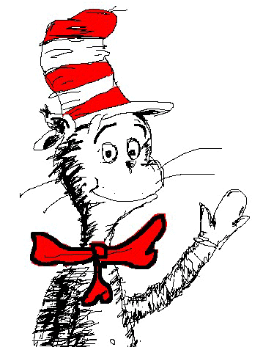
- Design a children’s book illustrating the following forms of government:

  - anarchy
  - theocracy
  - oligarchy
  - monarchy
  - dictatorship
  - democracy

- Your book should contain a definition for each term and an illustration of each term.

- Remember that this is a children’s book – so definitions and illustrations should be in
easy-to-understand language and should make sense to a younger crowd.

Types of Governments
Children’s Book

- Design a children’s book illustrating the following forms of government:

  - anarchy
  - theocracy
  - oligarchy
  - monarchy
  - dictatorship
  - democracy

- Your book should contain a definition for each term and an illustration of each term.

- Remember that this is a children’s book – so definitions and illustrations should be in
easy-to-understand language and should make sense to a younger crowd.

